Instructions:
This template uses form fields to organize responses to the required three-year planning prompts. You may easily navigate the template by clicking on each of the shaded fields or by using the Tab key.

This document has been protected to enable use of form fields and to guard against accidental edits to the template. Should the need arise, the document may be unlocked temporarily. Use cases may include adding charts, tables, or graphics to narrative sections, expanding Table 1, adding appendices, or updating the table of contents, among others. You may temporarily unlock the template by toggling the Protect Form button () on the Developer Tab on the Microsoft Office ribbon. The Developer Tab does not appear by default, so it must first be enabled in order to use this feature. Instructions for how to enable the Developer Tab may be found here: https://docs.microsoft.com/en-us/visualstudio/vsto/how-to-show-the-developer-tab-on-the-ribbon?view=vs-2017

Please note: Form fields will not work correctly unless form protection is on. Please be sure to remember to re-enable it once you have finished your work and before submitting to the AEP office.

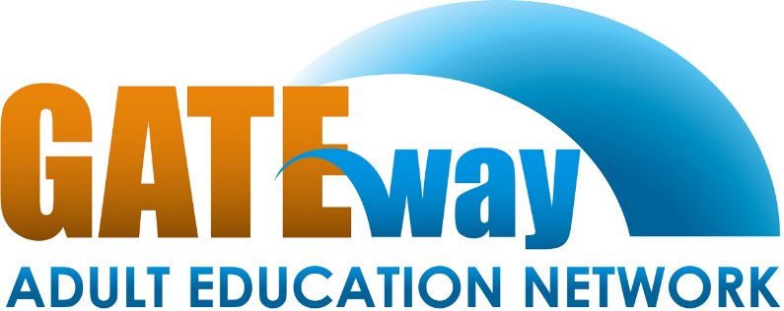
Section 1: Consortium Information
Pathways to
“Getting Adults into Training & Education”

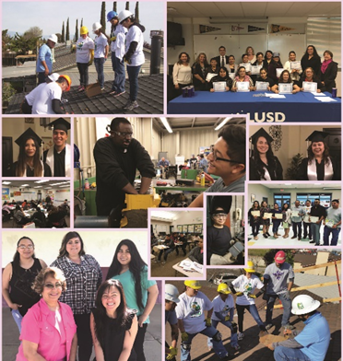
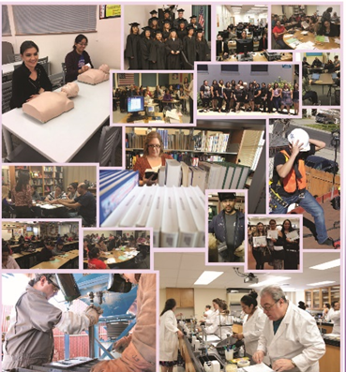
“Adult Education is one of the cornerstones of social investment effort, not only for our own people, but also for people in the community.”
Con Fauconnier
Vilma Reynoso
Consortium Coordinator

(209)325-2800
vreynoso@muhsd.org
mygaen.org

Submitted:6/6/19

Table of Contents
Section 1: Consortium Information ii
Section 2: Comprehensive Regional Three-Year Plan 1
2.1 Executive Summary 1
2.2 Pre-Planning Assessment 2
Table 1. Regional Service Providers 3
Table 2. Funding for Adult Education Programs and Services 4
2.3 Community Need and Customers 5
2.4 Identifying Goals and Strategies 6
Figure 1. Logic Model 7
Table 3. Progress Indicators 8
2.5 Piloting and Implementation 9

Section 2: Comprehensive Regional Three-Year Plan

2.1 Executive Summary
The Gateway Adult Education Network Consortium (GAEN) is one of the 71 adult education consortia in the state of California. GAEN region consist of a large, but lightly populated area in the San Joaquin Valley and includes Chowchilla (Northern Madera Co.)Mariposa, and Merced counties. An area of mountainous, agricultural, semi urban, urban and rural communities. Such diverse are provides opportunities for adult education expansion, but also raises challenges that such a diverse territory encompasses. GAEN regional demographics show that more than 55, 000 adults do not posses a high school diploma or equivalent out of 206, 907 adults. Merced Community College, Merced County Office of Education and the six school districts in the region will continue assist hundreds of people to become “important people” through the efforts of the Network entering 2020. Continuing and restoring basic education services after many were eliminated during flexibility, including English-as-a-Second Language, Adult Basic Education, High School Equivalency and diploma are the top priority for GAEN.
In order to address the needs of the students within the region, GAEN has created a three-year plan to improve adult education services for the next three years and beyond 2020. GAEN has selected goals to focus its efforts on maintain an effective collaborative process, enhancing successful transitions to college and career for students and better serve students with disabilities. This three year plan, also involve the implementation of new strategies, such adding an Individual Learning Plan that will be used across the region, increase the workforce and career services, and strengthen partnerships with local and regional agencies to increase student success.
Realistically, for the next three years most of the districts in this consortium will be working in continuing developing a lasting programs to meet the needs of adult learners.

2.2 Pre-Planning Assessment
Gateway Adult Education Network Consortium (GAEN) pre-planning process began fall 2008 with the GAEN Needs Assessment. GAEN members, community partners, students and community as a whole was survey and that helped GAEN members start the goal setting process. Each GAEN member completed the Self-Assessment provided by CAEP. All eight members participated on a Self-Assessment session and they carefully analyzed the needs of the region, their individual communities, adult learners, faculty, staff and other stake holders.
GAEN Needs Assessment
Click the picture to read the full assessment

GAEN Program Quality Self-Assessment
Click the picture to read the full assessment

Table 1. Regional Service Providers
Provider Name | Provider Type | Address or location(s) where AE services are provided | Program Areas |  |  |  |  |  |  |  | If other, provide a brief description of services provided
 |  |  | ABE | ASE | ESL | CTE | AWD | WR | PA | ACS
Dos Palos-Oro Loma USD | School District | 22368 South 6th St South Dos Palos |  |  |  |  |  |  |  |  | DPOL provides classes for studetns in ABE/ASE and ESL.
Gustine USD | School District | 685 Walllis Ave Gustine CA |  |  |  |  |  |  |  |  | Gustine provides classes for studetns in ABE/ASE and ESL.
Le Grand HSUSD | School District | 12961 Le Grand Road, Le Grand CA |  |  |  |  |  |  |  |  | Le Grand provides classes for studetns in ABE/ASE and ESL.
Los Banos USD | School District | 1717 South 11th Street Los Banos |  |  |  |  |  |  |  |  | Los BanosDPOL provides classes for for studetns in ABE/ASE and ESL.
Mariposa CUSD | School District
Merced CCD | Community College | 690 West 19St. Merced CA |  |  |  |  |  |  |  |  | MCCD provides a variety of classes in different pasrt of the county.
Merced COE | County Office | 732 West 13th St Merced CA |  |  |  |  |  |  |  |  | Merced COEprovides a variety of classes in different pasrt of the county.
Merced UHSD | School District | 50 East 20 Strett Merced CA |  |  |  |  |  |  |  |  | Merced UHSDprovides a variety of classes in different pasrt of the county.

Table 2: List of Adult Education Providers and Program Offerings

Member | Area of Service | Program Offerings
Dos Palos- Oro Loma  Joint Unified  School District | Dos palos  South Dos Palos  Oro Loma | Adult Basic Education/Adult Secondary Education  High School Diploma  ESL  Citizenship
Gustine Unified  School District | Gustine  Santa Nella  Stevinson | Adult Basic Education/Adult Secondary Education  High School Diploma  ESL
Le Grand Union  High School District | Le Grand  Plainsburg  Planada | Citizenship  ESL  GED Preparation  High School Diploma  CTE Beginning Welding
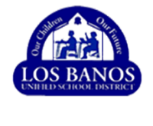  Los Banos Unified School District | Los Banos | High School Diploma  GED
Mariposa County  Unified School District | Mariposa  El Portal | High School Diploma  ESL
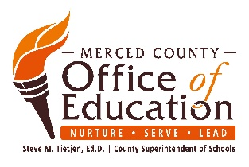  Merced County Office of Education | Atwater  Los Banos  Merced | CTE  Foundations in Early Education  Marketing and Customer Service  Construction Technology | Automotive Technology  Logistics and Warehousing  Culinary Experience
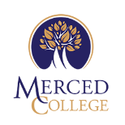  Merced Community College District | Atwater  Chowchilla  Delhi  Livingston  Merced  Planada  Winton | College Pre/Math I, II. II, IV  ESL  Career & Life Planning Healthy  Intro to Microcomputers  Microcomputers & Business  Basic Skills and GED Preparation  Medical Assisting | Bus Driver Training  College Prep English 1 Reading  College Prep English 2 Writing  Citizenship Preparation  Introduction to Microcomputers and Basic Computers Applications  Daily Livings Skills  Reading and Computers I & II
Merced Union High School District | Atwater  Livingston  Merced  Winton | ESL  VSEL  Conversation Café  Citizenship Preparation  ABE/AES  High School Diploma  GED Preparation  Family Literacy  Medical Administrative Assistant  Introduction to Office Administrative Assistant | Computer Fundamentals/IC3 Certification  Google Basics  Green Technology & Energy Conservation  CPR/First Aid  Serve Safe Certification/ Workplace Safety  Computerized Office Technology  Career Foundations  Clerical/Microsoft Office Specialist (MOS)

Gateway Adult Education Network Consortium

Table 3. Funding for Adult Education Programs and Services
Source and Type of Funds | Funding Estimates FY2019-20 | Funding Estimates FY2020-21 | Funding Estimates FY2021-22
State / Federal Funding
AEP | $3,379,105 | $3,379,105 | $3,379,105
CalWORKs | $0 | $0 | $0
CCD Apportionment | $0 | $0 | $0
Corrections | $0 | $0 | $0
LCFF / District Funds | $0 | $0 | $0
Perkins V | $0 | $0 | $0
WIOA II | $0 | $0 | $0
Other | $0 | $0 | $0
 | $0 | $0 | $0
 | $0 | $0 | $0
 | $0 | $0 | $0
 | $0 | $0 | $0
 | $0 | $0 | $0
 | $0 | $0 | $0
Total | $0 | $0 | $0

Dos Palos- Oro Loma

Table 4. Funding for Adult Education Programs and Services

Source and Type of Funds | Funding Estimates FY2019-20 | Funding Estimates FY2020-21 | Funding Estimates FY2021-22
State / Federal Funding
AEP | $80,056 | $80,056 | $80,056
CalWORKs | $0 | $0 | $0
CCD Apportionment | $0 | $0 | $0
Corrections | $0 | $0 | $0
LCFF / District Funds | $0 | $0 | $0
Perkins V | $0 | $0 | $0
WIOA II | $0 | $0 | $0
Other | $0 | $0 | $0
 | $0 | $0 | $0
 | $0 | $0 | $0
 | $0 | $0 | $0
 | $0 | $0 | $0
 | $0 | $0 | $0
 | $0 | $0 | $0
Total | $0 | $0 | $0

Gustine

Table 5. Funding for Adult Education Programs and Services

Source and Type of Funds | Funding Estimates FY2019-20 | Funding Estimates FY2020-21 | Funding Estimates FY2021-22
State / Federal Funding
AEP | $187,646 | $187,646 | $187,646
CalWORKs | $0 | $0 | $0
CCD Apportionment | $0 | $0 | $0
Corrections | $0 | $0 | $0
LCFF / District Funds | $0 | $0 | $0
Perkins V | $0 | $0 | $0
WIOA II | $0 | $0 | $0
Other | $0 | $0 | $0
 | $0 | $0 | $0
 | $0 | $0 | $0
 | $0 | $0 | $0
 | $0 | $0 | $0
 | $0 | $0 | $0
 | $0 | $0 | $0
Total | $0 | $0 | $0

Le Grand

Table 6. Funding for Adult Education Programs and Services

Source and Type of Funds | Funding Estimates FY2019-20 | Funding Estimates FY2020-21 | Funding Estimates FY2021-22
State / Federal Funding
AEP | $78,573 | $78,573 | $78,573
CalWORKs | $0 | $0 | $0
CCD Apportionment | $0 | $0 | $0
Corrections | $0 | $0 | $0
LCFF / District Funds | $0 | $0 | $0
Perkins V | $0 | $0 | $0
WIOA II | $0 | $0 | $0
Other | $0 | $0 | $0
 | $0 | $0 | $0
 | $0 | $0 | $0
 | $0 | $0 | $0
 | $0 | $0 | $0
 | $0 | $0 | $0
 | $0 | $0 | $0
Total | $0 | $0 | $0

Los Banos

Table 7. Funding for Adult Education Programs and Services

Source and Type of Funds | Funding Estimates FY2019-20 | Funding Estimates FY2020-21 | Funding Estimates FY2021-22
State / Federal Funding
AEP | $41,850 | $41,850 | $41,85
CalWORKs | $0 | $0 | $0
CCD Apportionment | $0 | $0 | $0
Corrections | $0 | $0 | $0
LCFF / District Funds | $0 | $0 | $0
Perkins V | $0 | $0 | $0
WIOA II | $0 | $0 | $0
Other | $0 | $0 | $0
 | $0 | $0 | $0
 | $0 | $0 | $0
 | $0 | $0 | $0
 | $0 | $0 | $0
 | $0 | $0 | $0
 | $0 | $0 | $0
Total | $0 | $0 | $0

Mariposa

Table 8. Funding for Adult Education Programs and Services

Source and Type of Funds | Funding Estimates FY2019-20 | Funding Estimates FY2020-21 | Funding Estimates FY2021-22
State / Federal Funding
AEP | $197,040 | $197,040 | $197,040
CalWORKs | $0 | $0 | $0
CCD Apportionment | $0 | $0 | $0
Corrections | $0 | $0 | $0
LCFF / District Funds | $0 | $0 | $0
Perkins V | $0 | $0 | $0
WIOA II | $0 | $0 | $0
Other | $0 | $0 | $0
 | $0 | $0 | $0
 | $0 | $0 | $0
 | $0 | $0 | $0
 | $0 | $0 | $0
 | $0 | $0 | $0
 | $0 | $0 | $0
Total | $0 | $0 | $0

MCCD

Table 9. Funding for Adult Education Programs and Services

Source and Type of Funds | Funding Estimates FY2019-20 | Funding Estimates FY2020-21 | Funding Estimates FY2021-22
State / Federal Funding
AEP | $776,995 | $776,995 | $776,995
CalWORKs | $0 | $0 | $0
CCD Apportionment | $247,631 | $247,631 | $247,631
Corrections | $0 | $0 | $0
LCFF / District Funds | $1,173,006 | $1,231,657 | 41,293,239
Perkins V | $0 | $0 | $0
WIOA II | $0 | $0 | $0
Other | $0 | $0 | $0
In-Kind | $1,288,306 | $1,288,306 | $1,288,306
 | $0 | $0 | $0
 | $0 | $0 | $0
 | $0 | $0 | $0
 | $0 | $0 | $0
 | $0 | $0 | $0
Total | $3,485,938 | $3,544,589 | $3,606,171

MCOE

Table 10. Funding for Adult Education Programs and Services

Source and Type of Funds | Funding Estimates FY2019-20 | Funding Estimates FY2020-21 | Funding Estimates FY2021-22
State / Federal Funding
AEP | $313,338 | $313,338 | $313,338
CalWORKs | $0 | $0 | $0
CCD Apportionment | $0 | $0 | $0
Corrections | $0 | $0 | $0
LCFF / District Funds | $0 | $0 | $0
Perkins V | $0 | $0 | $0
WIOA II | $0 | $0 | $0
Other | $0 | $0 | $0
Other State Grants | $999,439 | $999,439 | $999,439
In-kind | $423,360 | $423,360 | $423,360
 | $0 | $0 | $0
 | $0 | $0 | $0
 | $0 | $0 | $0
 | $0 | $0 | $0
Total | $1,736,137 | $1,736,137 | $1,736,137

MUHSD

Table 11. Funding for Adult Education Programs and Services

Source and Type of Funds | Funding Estimates FY2019-20 | Funding Estimates FY2020-21 | Funding Estimates FY2021-22
State / Federal Funding
AEP
CalWORKs | $325,000 | $325,000 | $325,000
CCD Apportionment | $0 | $0 | $0
Corrections | $0 | $0 | $0
LCFF / District Funds | $0 | $0 | $0
Perkins V | $0 | $0 | $0
WIOA II | $0 | $0 | $0
Other | $0 | $0 | $0
 | $0 | $0 | $0
 | $0 | $0 | $0
 | $0 | $0 | $0
 | $0 | $0 | $0
 | $0 | $0 | $0
 | $0 | $0 | $0
Total | $0 | $0 | $0

2.3 Community Need and Customers
Gateway Adult Education Consortium conducted a Needs Assessment by an independent consultant. A copy of the complete assessment will be attached to the 3 Year Plan. Below is the Executive Summary.
GAEN Needs Assessment
EXECUTIVE SUMMARY
The purpose of this document is to paint a current and accurate picture of the Adult Education System within the region served by the Gateway Adult Education Network (GAEN). In order to best serve its current students and attract new students, GAEN must be able to recognize and quantify its strengths and opportunities. As GAEN embarks on the development of its next 3-Year Plan (2019-2022), it was agreed by the GAEN Board that a comprehensive needs assessment should be undertaken in order to inform the Plan and to ensure that any future actions are directly responsive to community needs. The process of conducting the assessment took place between May 2018 and December 2018. During that time period, 27 individuals were interviewed (some on multiple occasions) and 395 individuals were surveyed. In tandem with the survey/interview process, a review of demographic information, existing literature, and best practices was undertaken. The resulting document includes suggestions for action that the consortium can take, both in the short and long-term, to address the gaps identified herein.
GAEN Need Assessment
Click the picture to read the full assessment

Figure 1: Regional Demographics
Gateway Adult Education Network Consortium evaluated the region demographics and compared to the current students to decide what specifics populations should be observant during the next three years. Please see the figure below.
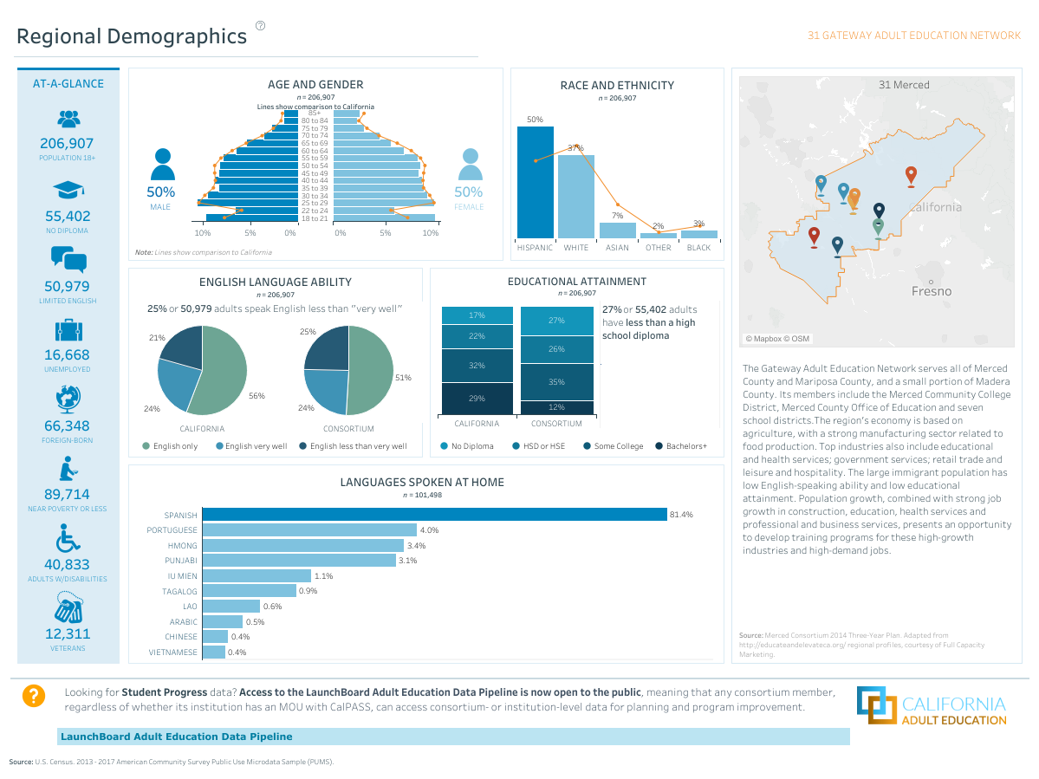

Figure 2: Labor Market Outlook by Industry

Figure 3. Top Occupations and Top 10 Fastest Growing Occupations

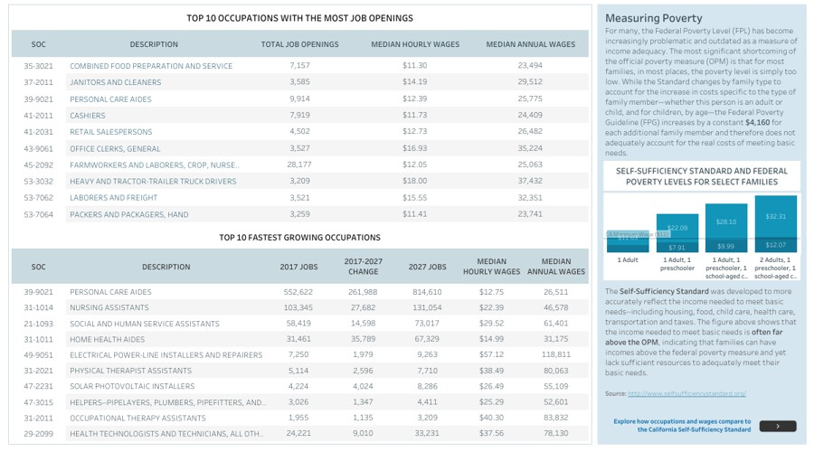

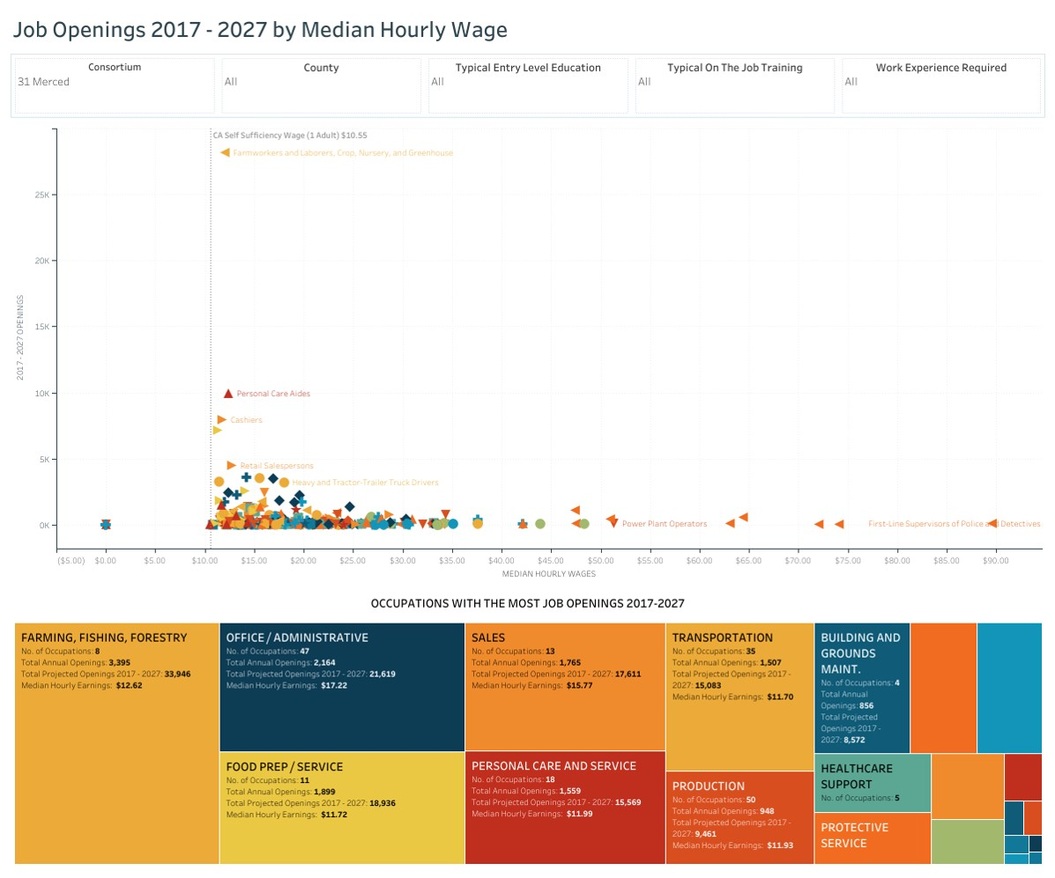
Figure 4. Job Openings 2017-2027

2.4 Identifying Goals and Strategies
Goal 1. Consortium to maintain an effective collaborative process for planning, implementing and accountability.
Objective/Strategies:
- Environmental Scan of what is being offered and what is being spent by who including as much as we know about community sources outside of GAEN.
- Using the Needs Assessment as a resource to evaluate programs being offered, gaps in services and potential solutions.
- SWOT analysis completed.
- Ensure that all spending is promoting the Seven Elements of Quality Adult Education.
Goal 2. Consortium students to complete individualized educational plans that reflect an informed understanding of their educational and career options.
By August 2019, the Consortium will develop an individualized educational plan to be used by all students to map out their education and career goals.
- Develop Programs of Study (POS) (that shows aligned and articulated work) to be used with Individualized Learning Plans (ILP) that show a transition from the course the student is currently enrolled in to post-secondary or workforce.
- Develop an Individualized Learning Plan that addresses both ABE and CTE.
- Develop internal referral form for students so they do not get lost moving from one consortium program to another.
Goal 3. Consortium programs to provide educational services to Adults with Disabilities
By June 2020, the Consortium shall have in place an educational and career program plan for adult students with disabilities (Aw/D).
- Align ABE courses across the consortium to develop a Program of Study for adults with disabilities. This will give community agencies a pathway to refer students (part of goal 7).
- Develop a CTE culinary program to serve mild to moderate adults with disabilities.

Figure 1. Logic Model
Goal Statement: 1. Consortium to maintain an effective collaborative process for planning, implementing and accountability.
Our overall direction and focus for the program cycle relative to the target populations and problems we seek to address
Inputs | Activities | Outputs | Immediate (Short-Term) Outcomes | Intermediate Outcomes | Long-Term Outcomes / Impact
In order to accomplish our set of activities we will need the following: | In order to address our problem or asset we will accomplish the following activities: | We expect that once accomplished, these activities will produce the following evidence or service delivery: | We expect that if accomplished these activities will lead to the following changes in the next year | We expect that if accomplished these activities will lead to the following changes in 1-3 years | We expect that if accomplished these activities will lead to the following changes in 3-5 years
All consortium members to understand their role as a member and thoroughly reading the needs assessment of our consortia to lead us to understanding the main goal of the consortium | - Environmental Scan of what is being offered and what is being spent by who including as much as we know about community sources outside of GAEN.  - Using the Needs Assessment as a resource to evaluate programs being offered, gaps in services and potential solutions.  - SWOT analysis completed.  - Ensure that all spending is promoting the Seven Elements of Quality Adult Education. | New Proposal for Funding template that details on program specifics and what money is being spent on which of the 7 Categories.  Community Advisory Committee to address what is currently being done by the consortium and get feedback on what is still needed.  Complete a SWOT analysis | Better address gaps in services in order to generate an appropriate program plan. | Yearly program plans will address need gaps in our area.. | All programs show growth or will be re-evaluated .

Assumptions | External Factors
1. District Office/Administration support.
2. Understanding on the duties and responsibilidades of a consortium membership
3. Duplication of services/saturation of services in specific areas

Table 3. Progress Indicators
Provide three to five SMART (Specific, Measurable, Attainable, Realistic, and Time-bound) objectives by which your consortium will assess progress and impact during the next three-year cycle. These objectives should map directly to your Logic Model activities, outputs, and / or outcomes, as these will be a driving factor for annual plans throughout the funding period.
Example: By May 2019, increase the number of agencies that have aligned CTE pathways and developed comprehensive program maps from 2 to 10.
Goal 1. Consortium to maintain an effective collaborative process for planning, implementing and accountability.
Objective/Strategies:
- Environmental Scan of what is being offered and what is being spent by who including as much as we know about community sources outside of GAEN.
- Using the Needs Assessment as a resource to evaluate programs being offered, gaps in services and potential solutions.
- SWOT analysis completed.
- Ensure that all spending is promoting the Seven Elements of Quality Adult Education.
Goal 2. Consortium students to complete individualized educational plans that reflect an informed understanding of their educational and career options.
By August 2019, the Consortium will develop an individualized educational plan to be used by all students to map out their education and career goals.
- Develop Programs of Study (POS) (that shows aligned and articulated work) to be used with Individualized Learning Plans (ILP) that show a transition from the course the student is currently enrolled in to post-secondary or workforce.
- Develop an Individualized Learning Plan that addresses both ABE and CTE.
- Develop internal referral form for students so they do not get lost moving from one consortium program to another.
Goal 3. Consortium programs to provide educational services to Adults with Disabilities
By June 2020, the Consortium shall have in place an educational and career program plan for adult students with disabilities (Aw/D).
- Align ABE courses across the consortium to develop a Program of Study for adults with disabilities. This will give community agencies a pathway to refer students (part of goal 7).
- Develop a CTE culinary program to serve mild to moderate adults with disabilities.

2.5 Piloting and Implementation

Goal 1. Consortium to maintain an effective collaborative process for planning, implementing and accountability.
Objective/Strategies:
- Environmental Scan of what is being offered and what is being spent by who including as much as we know about community sources outside of GAEN.
- Using the Needs Assessment as a resource to evaluate programs being offered, gaps in services and potential solutions.
- SWOT analysis completed.
- Ensure that all spending is promoting the Seven Elements of Quality Adult Education.

Goal 2. Consortium students to complete individualized educational plans that reflect an informed understanding of their educational and career options.
By August 2019, the Consortium will develop an individualized educational plan to be used by all students to map out their education and career goals.
- Develop Programs of Study (POS) (that shows aligned and articulated work) to be used with Individualized Learning Plans (ILP) that show a transition from the course the student is currently enrolled in to post-secondary or workforce.
- Develop an Individualized Learning Plan that addresses both ABE and CTE.
- Develop internal referral form for students so they do not get lost moving from one consortium program to another.

Goal 3. Consortium programs to provide educational services to Adults with Disabilities
By June 2020, the Consortium shall have in place an educational and career program plan for adult students with disabilities (Aw/D).
- Align ABE courses across the consortium to develop a Program of Study for adults with disabilities. This will give community agencies a pathway to refer students (part of goal 7).
- Develop a CTE culinary program to serve mild to moderate adults with disabilities.

